Al-Zaytoonah University of Jordan
Faculty of Science and Information Technology



E-registration system

By: Abdulrahman Shahrori

Supervisor: Dr. Khulood Abu Mariah

2026

Project Team

Project Manager:

Student Name: Abdulrahman Ahmed Shahrori

Profile: 202520034@std-zuj.edu.jo

(Project manager | Communication and team coordination | Web development and system design | System architecture and project coordination)

Project Member 1:

Student Name: Mahmoud Abu Yahya

Profile: 20241076@std-zuj.edu.jo

(Technical lead | Problem solving, Teamwork | Software architecture, quality assurance and system design | Implementation and quality assurance)

Project Member 2:
Student Name: Abdulrahman Omar Theeb

Profile: 202520052@std-zuj.edu.jo

(Documentation specialist | Attention to detail, research | Documentation, analysis | Requirements gathering and documentation)

Abdulrahman Shahori
Table of Contents
‎ List of Tables.....................................................................................................................................5
List of Figures....................................................................................................................................6
Abstract..............................................................................................................................................7
List of Abbreviations and Terminologies…………………………………………………………..8
Chapter One …………………........................................................................................................9
1.1 Introduction ………………………………………………………………………………….....9
1.2 Background..................................................................................................................................9
  - Business Model ..........................................................................................................................9
1.3.1 Problem Definition.............................................................................................................9
1.3.2 Proposed System...............................................................................................................10
1.3.3 Project Scope….................................................................................................................10
1.3.4 Objectives.........................................................................................................................11
1.3.5 Motivations.......................................................................................................................11
1.4 Stakeholders Analysis...............................................................................................................11
1.5 Environment..............................................................................................................................11
1.5.1 Tools Needed…………………………………………………………………………....11
1.5.2 Hardware Specification…………………………………………………………………12
1.6 Project Management..................................................................................................................12
1.6.1 Project Schedule...............................................................................................................12
1.6.2 Project Risk......................................................................................................................12
1.7 Summary.............................................................................................................................13
Chapter Two: Systems Planning and Analysis Phase...................................................................14
2.1 Introduction...............................................................................................................................14
2.2 Planning Phase..........................................................................................................................14
2.2.1 Project Scope…………………………………………………………………………...14
2.2.1.1 Project Boundaries…………………...…………………………………………14
2.2.2 Project Plan……………………………………………………………………………..14
2.3 Analysis Phase...........................................................................................................................16
2.3.1 Gathering Requirements………………………………………………………………...16
2.3.2 Analyzing and Validating Requirements………………………………………………..16
2.4 System Requirements Specifications ………………………………………………………....17
2.4.1 Functional Requirements.................................................................................................17
2.4.2 Non- Functional Requirements........................................................................................20
2.5 Summary....................................................................................................................................20
Chapter Three: System Design Phase…………...........................................................................21
3.1 Introduction...............................................................................................................................21
3.2 Design Phase.............................................................................................................................21
3.2.1 Data Flow Diagram................................................................................................................21
3.2.1.1 DFD Context Diagram..............................................................................................22
3.2.1.2 DFD 0 Diagram.........................................................................................................22
3.2.2 System UI (Concept)....................................................................................................23
3.3 Summary ……………………………………………………………………………………...24
Chapter Four: Conclusion and Future Work…………………………………………………….25
4.1 Introduction……………………………………………………………………………………25
4.2 Conclusion…………………………………………………………………………………….25
4.3 Future Work…………………………………………………………………………………...25
References………………………………………………………………………………………...26
Appendices……………………………………………………………………………………......27

LIST OF TABLES

Page

1.1 | Stakeholders | 9
2.1 | Resource allocation | 14

LIST OF FIGURES

Page

1.1 | Gantt chart | 12
2.1 | Work Breakdown Structure | 14
2.2 | Waterfall diagram | 15
3.1 | Context diagram (Level 0 DFD) | 20
3.2 | Level 1 DFD | 21
3.3 | System UI (1) | 21
3.4 | System UI (2) | 22

ABSTRACT

The current registration portal in our university has a lot of problems that lead students to resort to the traditional paper process. This project aims to create a course E-registration system that will automate the manual process and solve the problems that are in the current system. The system will provide a centralized online platform where students can browse available courses, check prerequisites, and register for classes. The application will be built using basic web technologies and an SQL database to ensure data persistence and integrity. It will feature clear and distinct user roles, including students’ self-service registration and heads of departments to manage course catalogs, student records and enrollment periods. The system will offer enhanced user experience with better performance, modern UI, and more accessibility settings. This project demonstrates significant potential to reduce administrative workload by up to 70%, eliminate traditional paper based procedures, and provide a user-friendly platform that addresses the specific needs of Jordanian higher education institutions. The system's compliance with ACID properties ensures data integrity while its scalability architecture supports future growth and expansion.
LIST OF ABBREVIATIONS AND TERMINOLOGIES

ACID | : Atomicity, Consistency, Isolation, Durability
DFD | : Data Flow Diagram
SDLC | : Software Development Life Cycle
WBS | : Work Breakdown Structure

Chapter 1: Introduction

  - Introduction
This is a course E-registration system that will make the registration process easier and automated with little to no human interference.

  - Background
Registration in Jordanian universities in general begins when students fill the unified admission coordination unit forum to apply to public Jordanian universities. Once the student in accepted, students shall follow up the advertisements on the university website to find out dates of applying for admission. Afterwards, students must pursue procedures with the admission and registration unit for their username, password and e-payment number. After paying required fees, the student will fill their information through the self-registration website. Next, the student will attend proficiency exams and once they pass them, their schedule will be prepared within 2 hours based on the exams’ results. Finally the student’s university identity card will be issued by the deanship of student affairs [1].

The registration process in our university, even though has an electronic portal, has a lot of problems which prevents it from fulfilling its purpose in many occasions, thus causing students to go to the university and register via traditional paper-based transactions.

  - Business Model

The E-registration system will fully automate the registration process, which will reduce workload on the administrative staff in the university. The system will offer many services to all users such as A.I assistance, notifications, and easier communication between staff. The system will also offer a support hotline for users in case the system crashes or fails.

    - Problem Definition

There are many systems in the current registration portal in our university. To start with, new students and transferring students must register their data and courses through the admission and registration staff windows, which increases workload on the staff. Second, the current system is not accepted by a wide portion of students, which also increases the number of students who register via bureaucratic procedures. All of the above leads to long student queues which the administrative staff have to manage which increases physical and psychological pressure on the staff.

    - Proposed System

This system aims to fully automate registration processes, fix many of the countless problems in the current system, and be acceptable to as many students as possible and to be able to run smoothly on mobile.

    - Project Scope

- Objective: to develop a system for students to register for courses online

- Deliverables:

The system is expected to deliver a functioning web-based system with a user manual and a system documentation.

- Constraints:
- Academic constraints: include compliance with university policies on student data. The system must integrate with existing university information systems and comply with educational data protection regulations.
- Limited budget: current budget constraints the ability to purchase expensive commercial software and acquire high-end server infrastructure.
- Time constraints: the project is required to be completed within 12 weeks to align with the academic calendar.
- Technical expertise: the development team has limited expertise with the tools used to develop the system and modern web development practices. This will require the team additional time to develop their skills and potential external consultation for complex integrations.

    - Project Purpose (Objectives)

The project’s main objective is to automate the registration process for regular students and also for new and transfer credit students, as well as reduce workload on the administrative staff during registration periods.

    - Motivations

The project’s main motivation is to reduce workload on administrative staff and eliminate the traditional paper-based registration procedures. Thus preventing students from lining up in long queues each semester. Also, the system will offer user-friendly interface which will encourage a larger number of students to register via the E-registration system.

  - Stakeholder Analysis

Role in Project | Stakeholder Name
Academic advisor | Dr. Khulood Abu Mariah
Instructor | Dr. Mohammed Al-Madi
Head of department | Dr. Wael Al-zaydat
Head of Admissions | Dr. Abeer Ahmad AL-Dabaybeh
Student | Omar Mikkawi
Student | Ahmed Abu Rweleh
Table 1.1 E-registration system stakeholders

  - Environment

The project environment refers to the external factors and conditions that can influence the project’s execution and results. It includes elements such as organizational culture, stakeholder expectations, regulatory requirements, technological infrastructure and economic considerations. [2]

    - Tools Needed (Used)
- Phoenix code: for creating the web-based system
- Draw io: for creating diagrams
- Moqups: for UI concept design

    - Hardware Specification

- Server requirements:
  - CPU: AMD Ryzen 9 9900X
  - RAM: 32 GBs DDR5
  - Storage: 1 TBs M.2 NVMe SSDs
  - OS: Linux

- Client requirements:
  - Web browser

  - Project Management

    - Project iteration schedule (Gantt chart)
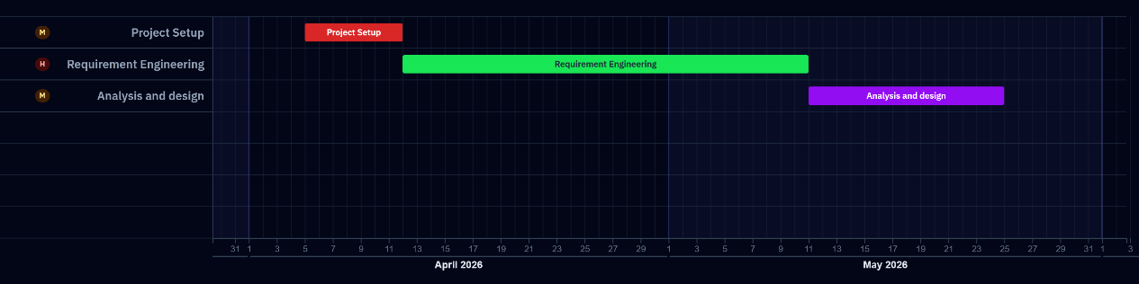
Fig 1.1 Gantt chart

    - Project Risks and Feasibility

- Technical risks:
There are technical risks that may delay the project, such as the team’s limited experience with programming, the difficulty with integrating the system with existing systems related to registration and most importantly potential security risks due to vulnerabilities in student data handling and also limited experience with data security.

- Project risks:

The project may face simple risks such as time constraints due to academic workload on the development team, limited testing resources due to limited budget, and the scope creep from adding new features.

- User risks:

Users may resist the new system for many reasons, to begin with, some faculty members may resist the new system because they prefer the current system and maybe even the fully manual process. Some student may still find the new system difficult. Lastly, there must be training requirements for different groups such as instructors, heads of departments and administrative staff.

- Technical feasibility:

The system only requires basic web development skills, university IT department support, and open source frameworks.

- Economic feasibility:

The system will use existing university resources for development, and the estimated development time is between 12 and 16 weeks. The system will offer long time cost savings because automation will reduce operating costs during registration periods.

  - Summary
This is an ambitious project which aims to create an E-registration system that will be more acceptable for students and offer more services to them and fully automate the registration process.

Chapter 2
System Planning and Analysis Phases

2.1 Introduction
This chapter presents the systematic approach used in the planning and analysis phases of the E-registration lifecycle, following the Waterfall methodology. The waterfall approach provides a clear and structured plan for development with clearly established phases, which will make development easier and clearer for the development team. [3]

2.2 Planning Phase or Inception Phase:

2.2.1 Project scope

The project scope is a detailed outline that includes a timeline, budget, assigned tasks, project stakeholders and workflow strategies. As a result, project managers can easily oversee each step in the project’s delivery. The scope keeps contributors on task, within budget, and on track to meet deadlines. [4]

2.2.1.1 Project boundaries:

The first version of the system will include add/withdraw course service for students, view schedules for all users and will also include an A.I assistant for users, which will offer recommendations and answers to some questions.

2.2.2 Project plan:

- Work Breakdown Structure:

A work breakdown structure is a classified breakdown of the project’s scope that divides complex work into manageable components. It also forms the backbone of project planning, it informs the schedule, guides the budget, and establishes the baseline for scope control as shown in figure 2.1 below [5].
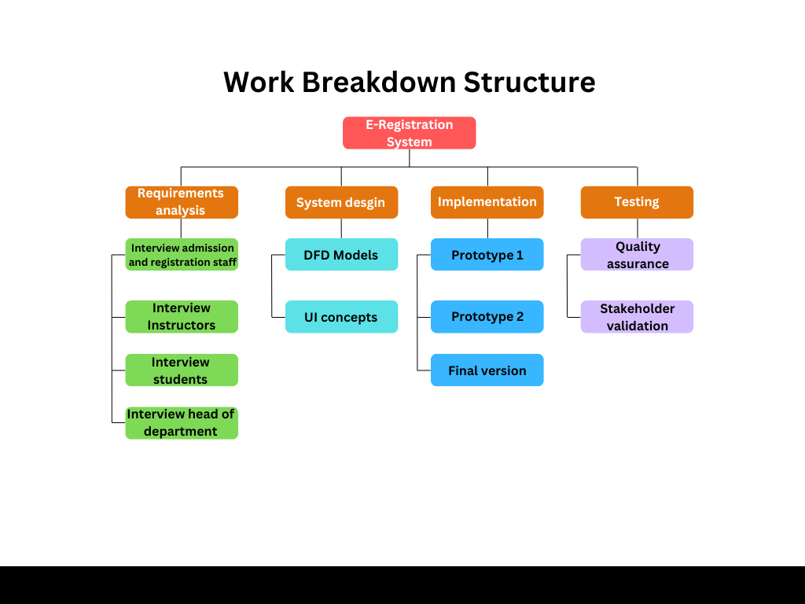
Fig 2.1 Work Breakdown Structure (WBS)

- Resource allocation:
Role | Mission
Developer | Coding features
Designers | Finalizing UI/UX
Testers | Validating prerequisites and registration logic
Table 2.1 resource allocation

- Waterfall diagram:
The waterfall diagram is a graphical representation of the software development plan which is based on the waterfall methodology. The waterfall methodology is a sequential project management approach where work flows through distinct phases in a linear order, with each phase completed before the next begins. The figure below displays the E-registration system’s plan, which follows the waterfall model. [6]
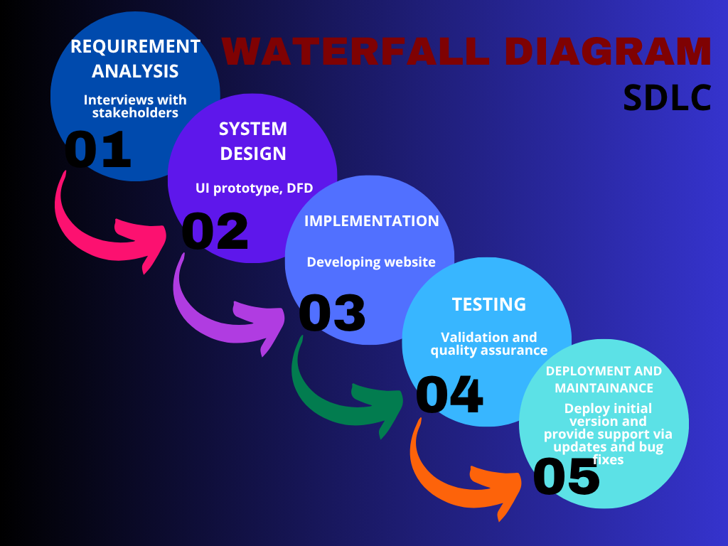
Fig 2.2 Waterfall diagram

2.3 Analysis Phase

2.3.1 Gathering requirements

The requirements for the E-registration system were gathered through interviews with key stakeholders, including potential student users and academic staff users. During these interviews, we were able to understand the problems the stakeholders face in the current system and the solutions they suggest, as well as get suggestions for new features to include in the new system. Unfortunately, we were not able to meet some stakeholders, so we had to resort to external sources and get the default requirements for the system. Assumptions will be marked by (assumptions)

2.3.2 Analyzing and validating requirements

The gathered requirements were carefully analyzed to ensure that they were clear, complete and feasible. Each requirement was reviewed to make sure there were no ambiguity, resolve any conflicts and verify that it was testable and aligned with the project’s goals.

2.4 Software Requirement Specification (SRS)

2.4.1 Functional requirements

2.4.1.1 Students:
- Chat bot for assistance and guidance: helps student find courses, ask about information, and get initial academic advice before contacting the academic advisor.
- Show available courses: prioritize displaying available courses over unavailable ones to avoid long scrolling and confusion while registering.
- Display how many hours the student still has left: display how many credit hours the student still has.
- Notify students when registration starts: this will make students know when registration starts, so they can register early instead of waiting to hear from other students and register late when most of the sections are full.
- Roadmap for new students: this feature will help students, especially freshmen, to figure out what courses they should prioritize in this semester.
- Access course syllabus: this will help students get an impression of the course before registering it, so they could decide whether they should register it or not.
- Option to hide unavailable courses: this option will hide courses the students can’t register or courses they completed so they can focus on courses they can register and make registration easier for them.
- Log-in via university E-mail: this is an important feature that will ensure that each student can access their own data and their data only. And will make sure that different students’ data will not mix up.
- Show instructor names: this will help students choose their sections according to which instructor they want to take the course with.
- E-payment methods: this service offers students the option to pay their debts online instead of having to wait in line in the accounting department.
- Support hotline: this feature will allow students to contact user support in case the system fails.
- Option to display course information: this option will show the students a small summary of the course’s syllabus to help the student catch a glimpse of the course.
- Add/withdraw courses: this is a crucial feature that will enable students to edit their schedule and add/remove courses.

2.4.1.2 Instructors:
- Chat bot: to help the instructor summarize long timetables and notifications.
- View course timetables: access a dashboard that shows timetables of the courses the instructor was assigned for.
- View course syllabus: access course syllabus to prepare for the semester.
- View new and older syllabus: access older syllabuses of courses to compare them with newer ones.
- Direct contact with head of department: the system must offer a direct hotline between instructors and head of department
- Send notifications about updates: the system must send notifications to the instructors when any change to their timetables happens, to ensure that every instructor stays up to date.

2.4.1.3 Head of department:
- Statistics for student prerequisites: to ensure academic preparedness and curriculum alignment.
- Reports about registration process: allows head of department to monitor enrollment trends, access course demand and ensure resource allocation aligns with student needs.
- Distribute timeline on instructors: ensures instructional consistency and coordinated course delivery.
- Show student information for supervision: it is critical for effective academic supervision and progress monitoring.

2.4.1.4 Academic advisor:
- AI assistance: helps the advisor find courses, generate comments and reports, and create schedules for students.
- View student academic profiles: access a dashboard that shows the student’s major, GPA, completed courses, transfer credits and remaining degree requirements (assumption)
- Monitor degree progress: run and view real-time degree audits that track a student’s progress based on their specific curriculum map (assumption)
- Approve or reject registration plans: review a student’s proposed schedule and electronically approve or deny it, then send a guide for better registration (assumption)
- Add advising notes: record private comments or notes on a student’s file regarding their academic plan or career goals (assumption)
- Generate reports: produce list of advisees, students at risk or students who have not yet met with an advisor.

2.4.1.5 Admission and registration staff: (Requirements in this section are assumptions based on outside sources because we were not able to get the requirements from the staff)
- Manage course catalog: edit and annotate courses and their information, or schedule courses for upcoming semesters
- Manage student records: oversee and maintain students’ records, including enrollment status and personal information
- Process academic actions: handle course adds/drops, process academic petitions and manage transfer credit evaluations
- Generate reports: compile and produce enrollment statistics, course capacity reports and other data for administrative use.
- Oversee registration process: administer and coordinate the overall registration schedule and procedures
- Manage user accounts: create and manage user accounts for students and faculty
- Perform degree audits: verify that students have met all requirements for graduation
- Handle system configuration: update and modify the student information system.

2.4.2 Non-Functional requirements:

- Performance: the new system will be 50% faster than the current system, which will display requested information within 2 seconds
- Security: all student data, including personal and registration data, should be encrypted both at transit and at rest.
- Reliability: the system should be always available during peak times (e.g. 9:00 A.M – 2:00 P.M) with 99% uptime
- Portability: the system should run on browsers without requiring additional plug-ins, and should run on multiple devices as smoothly as it runs on computers.
- Scalability: the system should be designed to adjust to a 20% annual increase in the number of students and courses without requiring a redesign.
- Maintainability: the system should be designed to allow for the addition of new features and modifications and shall be documented to industry standards.
- Data integrity: the system shall comply with the ACID properties for all database transactions and ensure accuracy and consistency of student records and registration data.
- Recoverability: in case of system failure, the system shall be capable of restoring all data and functionality from backups within 4 hours, with a maximum data loss of 15 minutes.

2.5 Summary
The planning phase established the foundation for our system. It began by defining the project’s scope, and setting clear objectives to improve the efficiency and accessibility of the registration process. Followed by interviews with key stakeholders who gave us the requirements and confirmed them. The project’s development plan was based on the waterfall model, which helped us in establishing clear stages and steps for development. Success in the project will be measured against the plan.
Chapter 3
System Design Phases

3.1 Introduction

This chapter presents the detailed system design of the E-registration system, transforming the gathered requirements into a comprehensive technical architecture.

3.2 Design Phase

3.2.1 DFD models:

Data Flow Diagrams (DFDs) map out the flow of information for any process or system. It uses defined symbols like rectangles, circles and arrows to show data inputs, outputs, storage points and the routes between each destination. A DFD can often visually “say” things that would be had to explain in words, and they work for both technical and non-technical audiences. [7] The figures below demonstrate the E-registration system’s DFDs.

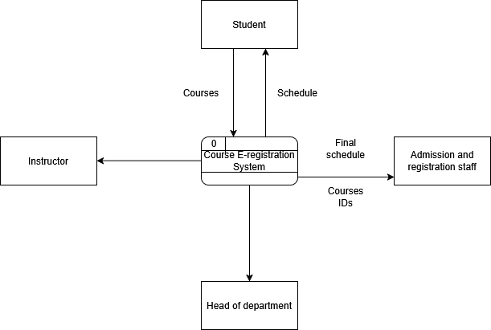
Fig 3.1 Level 0 DFD (Context DFD)

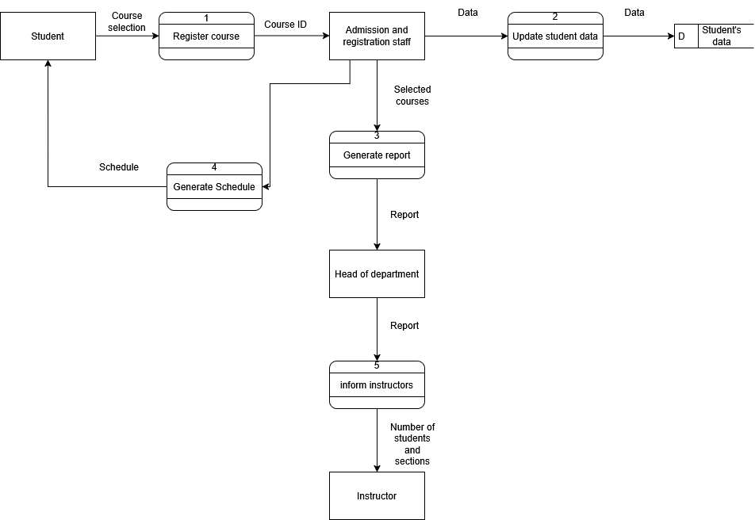

Fig 3.2 Level 1 DFD

3.2.2 System UI (Concept):
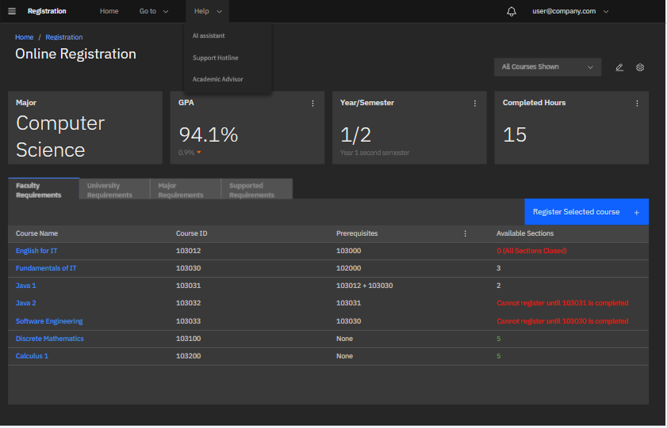
Fig 3.3 System UI (1)
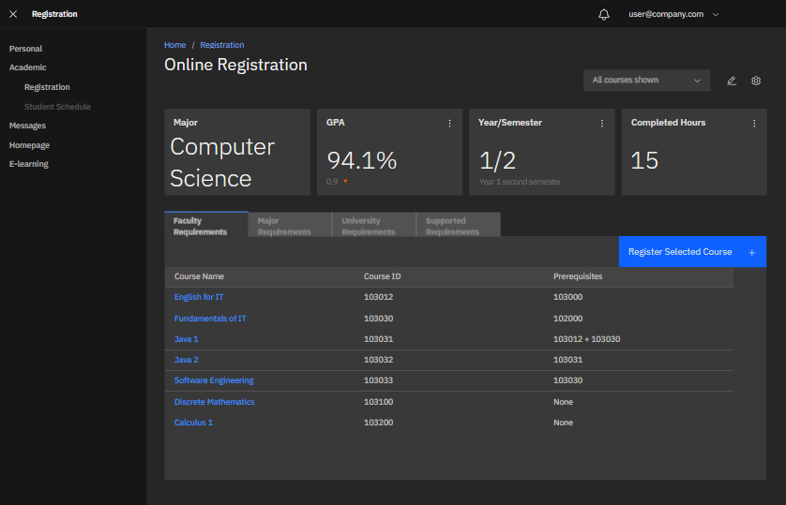
fig 3.4 System UI (2)

3.3 Summary

This comprehensive system design provides a detailed blueprint for implementing the E-registration system. This design phase successfully transforms abstract requirements into concrete specifications, enabling the development team to proceed with implementation confidence.
Chapter 4
Conclusion and Future Work

4.1 Introduction

This chapter serves as the culmination of the analysis, planning, and design conducted for the E-registration system project. This section summarizes the key achievements, challenges and insights gathered throughout the project life cycle.

4.2 Conclusion

This documentation discussed the course E-registration system, which will offer a lot of solutions for the problems in the current system, such as being unaccepted by a lot of users, being unhelpful for new students or for credit transfer students, and the imminent resort to traditional paper process. The new system will offer better performance, wider acceptability and better reliability.

4.3 Future Work

- Develop desktop and mobile applications: once resources are available, we will develop dedicated mobile and desktop applications which will improve user experience and accessibility
- Advanced AI implementation: the AI will be able to recommend courses and schedules to the students based on their performance and career goals, as well as recommendations from the academic advisor.
- Add offline course browsing and schedule planning: the system will offer schedule access for students even when offline to help students plan their schedules at any circumstance.
- Performance optimization: future versions will offer better performance in terms of speed, response time, and less probability of downtime.
References

Björn Michelsen, A Guide to Functional Requirements, January 12, 2026

Bohdan Durbak, Inception Phase of Software Projects with The APP Solutions, 11 May 2025

[1] University of Jordan, Registration Process - Jordanian Students, (n,d)

[2] Geeks for Geeks, What is the Project Environment?, 4 Mar, 2024

[3]Varela, Cristina, ed. Introduction to Software Engineering. 2nd ed. New York: 3G E-Learning, 2024.

[4]Adobe for business, Project scope — definition, best practices, examples, and more, 14 April 2025

[5]Stephanie Trovato, Work breakdown structure (WBS): definition, examples, steps, and templates [2026 guide], February 22, 2026

[6]Sarah Laoyan, Waterfall project management methodology, phases, and guide, 5 September 2025.

[7]Lucidchart, What is a Data Flow Diagram, (n.d)

APPENDICES

Appendix A
Code

Appendix B
Use Case Figures

Appendix c
System Screens

Appendix d
System Reports

